A Sponsor's Gift: One Student's Story

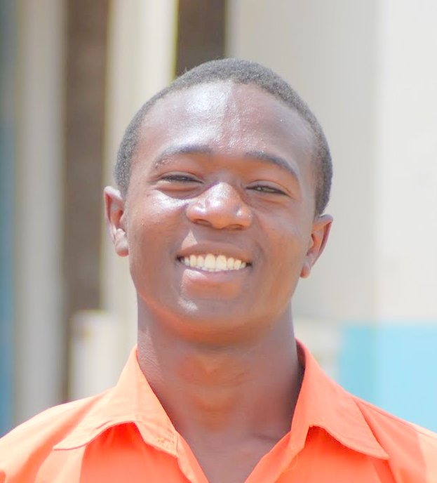
Allenken Bati Olango felt his life was over when he dropped out of school in 2009. He had attended primary school in Nairobi's Kibera slums, where the family was living. At the top of his class in primary, he continued into high school. But in his second year, the family's world was turned upside down during Kenya's 2008 post-election violence.

Bati's mother died and their home was burned to the ground during the civil strife. Shortly thereafter, his father had a stroke, which left him disabled and unable to work.
Without shelter or income, the family returned "home" to Kendu Bay, where a local church built them a primitive two-room house to shelter an extended family of thirteen. Bati, the eldest of ten children, took whatever menial jobs he could find, including garden work at the home of a local teacher. The teacher noticed Bati's work ethic and strong command of English. Hearing his story, she encouraged him to return to school and re-sit his exams in hopes he could qualify for a KSHP scholarship.

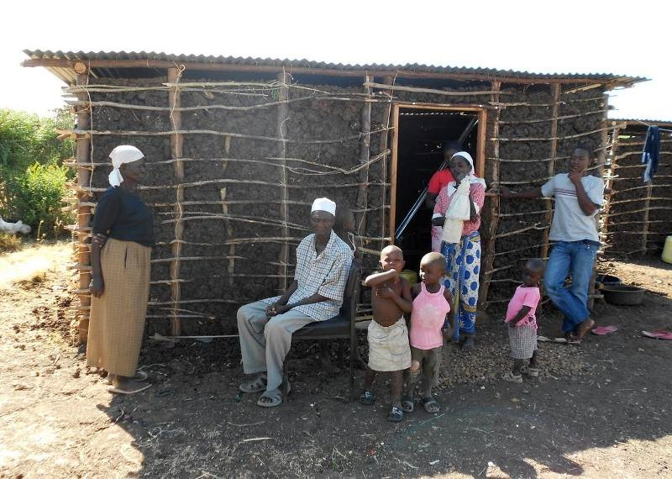
Bati's home in Kendu Bay
So, at age 16, Bati enrolled again in primary school to repeat grade eight. The headmaster also saw Bati's potential and mentored his progress.

Bati excelled on his year-end exams and was invited to attend Maranda Boys High, the top high school in Nyanza Province; a 'Princeton' among Kenya's high schools. Thanks to a sponsor's support, Bati entered Maranda Boys a proud freshman at age 17.

This year, Bati graduated with high honors from Maranda Boys and will attend university on full government scholarship. A secure future for Bati’s entire family began with a sponsor’s support of his high school education.

